**Spring Boot With MongoDB CRUD Example**

In this tutorial we are going to see how to integrate MongoDB in our spring boot application as we already integrated MySQL and Oracle. So now how to integrate MongoDB? That is the NoSQL database in our spring boot application.

We'll see that. So first we need to download the MongoDB based on your operating system as I am using windows here, by default it will find whether it is 64 or 32 bits.

Now open and check mongodb server---

Open mongosh in command prompt. We can see it’s running on port : **27017**

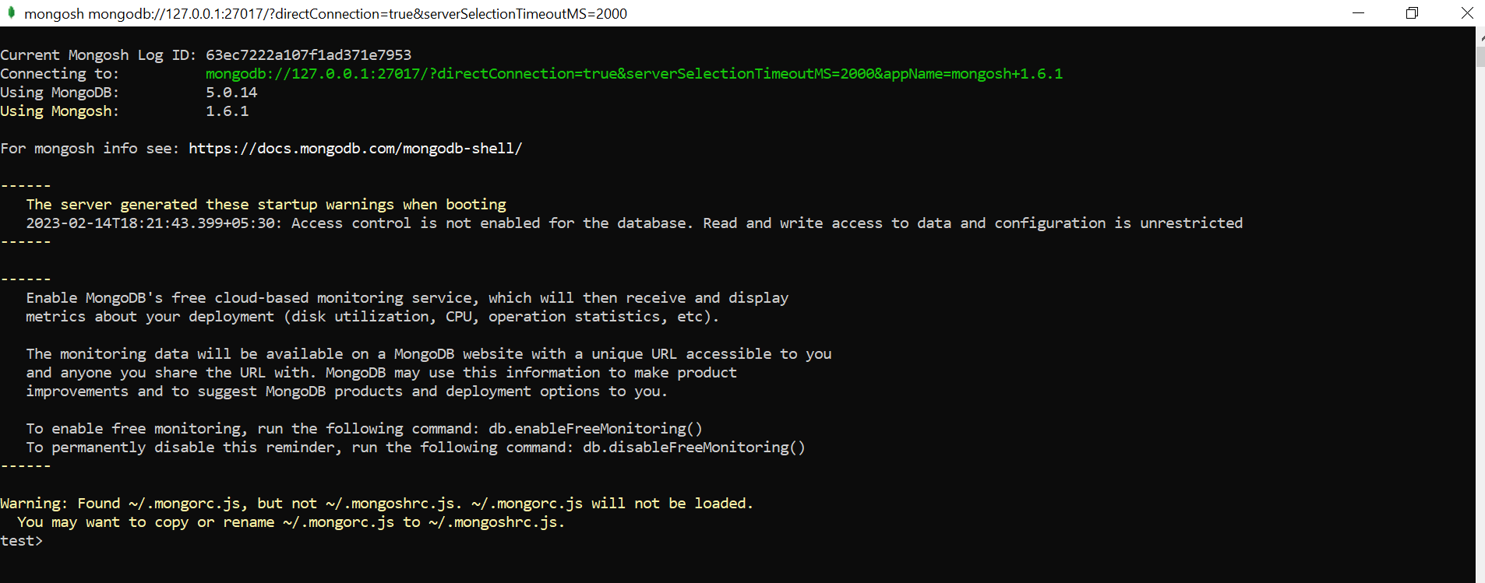

So, this is the installation step we need to follow before work with MongoDB application. Okay, so let's create one small application and we'll integrate with MongoDB. So, let's create one project, spring starter project.

Application : **spring-mongodb**

Dependencies : **Lombok, Web, DevTools, Spring Data MongoDB**

Open MongoDB Compass Community which is a MongoDB GUI.

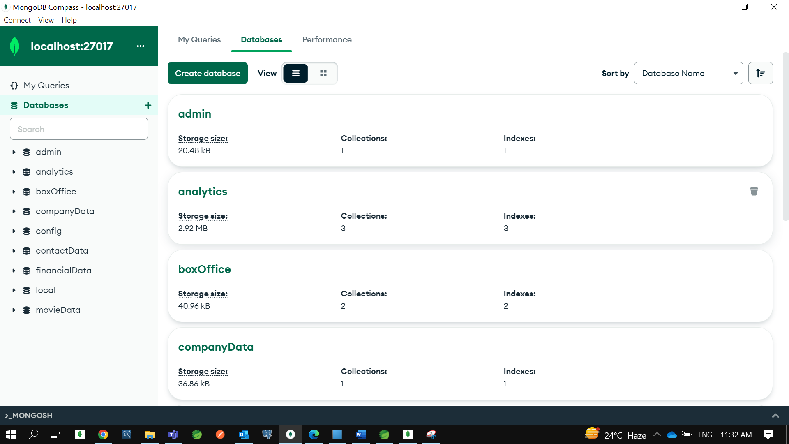

Let’s create a new database **BookStore** with a collection name **Book**.

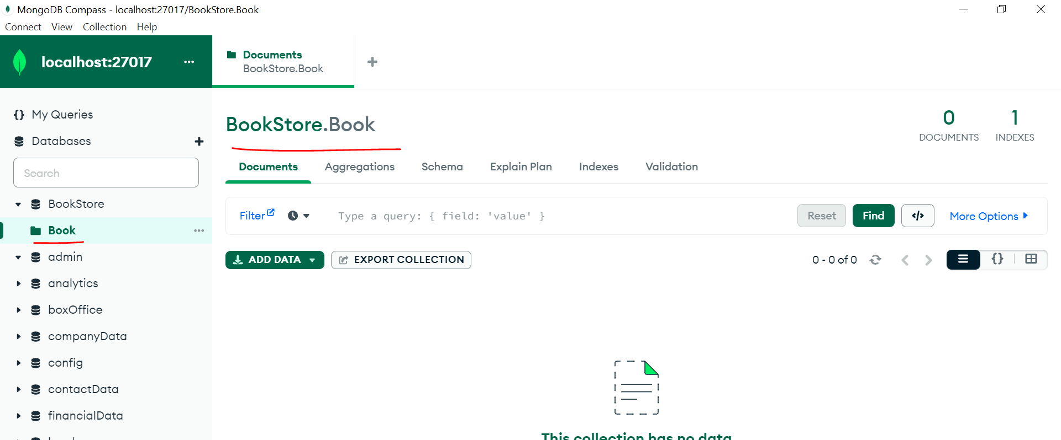

Now in STS let’s create a packages **resource(controller)**, **model** and **repository**. In traditional we are calling Table so in Mongo DB it’s a **Collection**.

Let’s create a model class.

In our traditional DB we were using annotation @**Entity** so for MongoDB let’s use @**Document** and as a parameter we need to use **Collection** name.

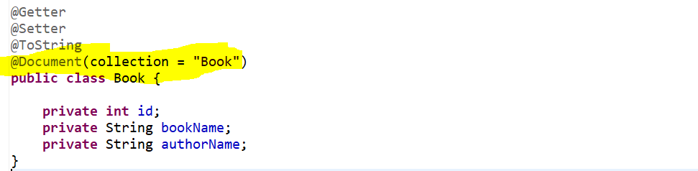

Now let’s create a repository. in a traditional while we were working with Spring- Data JPA we were extending our repository with JPARepository but here in case of MongoDB we need to extend with **MongoRepository** bcz we are using **Spring Data Mongo**.

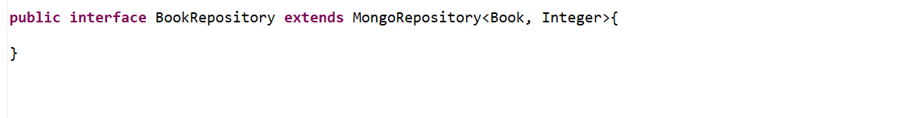

Now, let’s create a resource or a controller to handle the Http Request:-

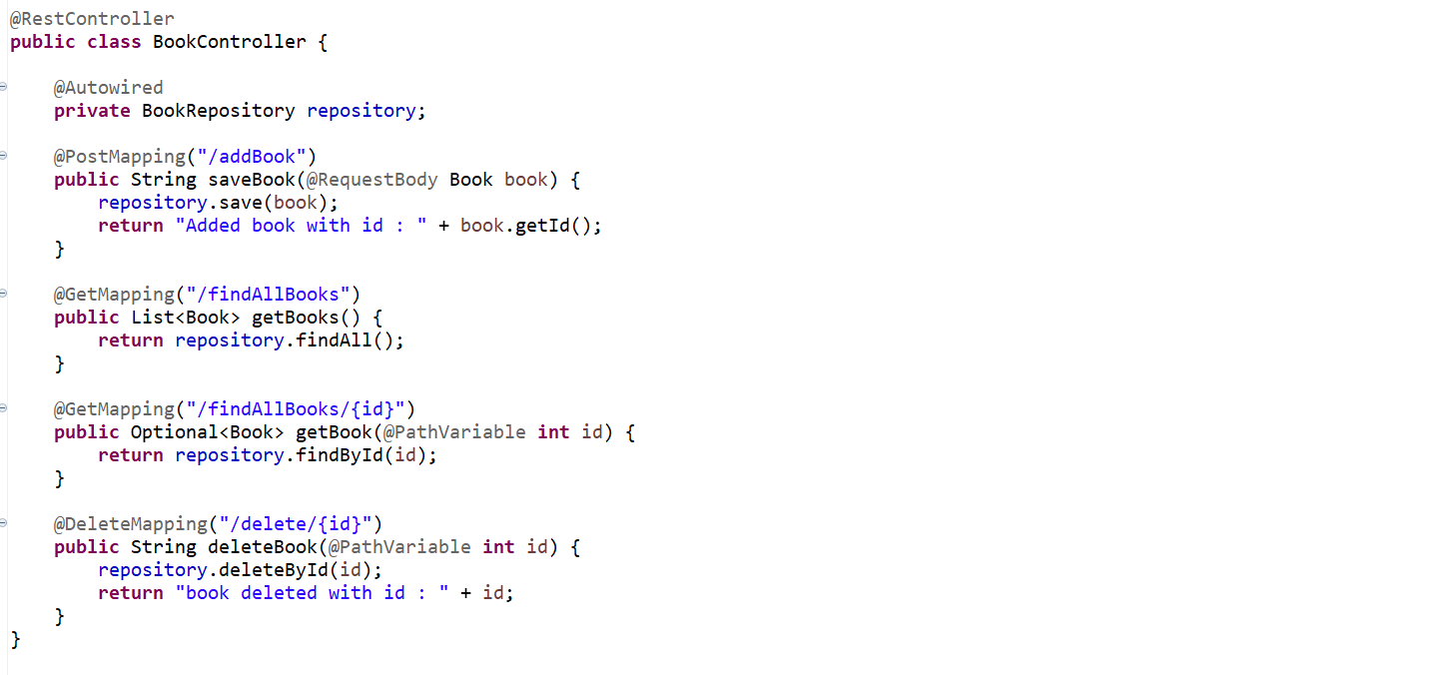

Now we need to add configuration details about the Mongo DB –

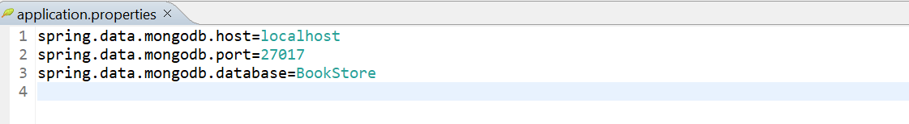

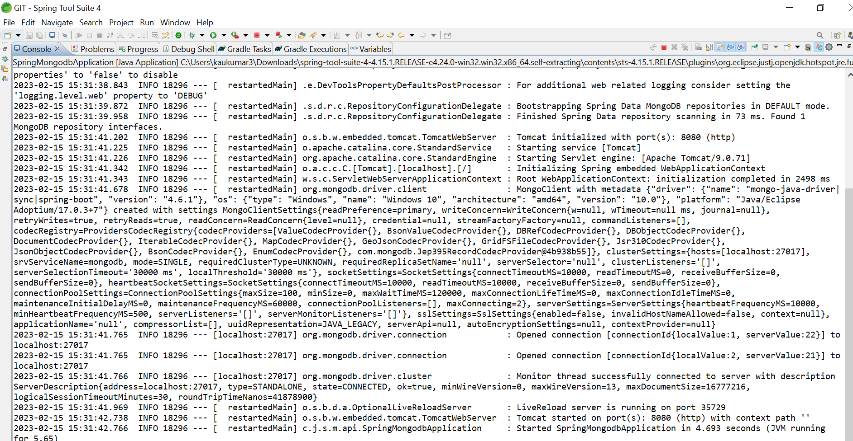

We can see our service is up and running on port 8080… let’s add few of the Book in our collection **Book** for Database **BookStore**.

<http://localhost:8080/addBook>

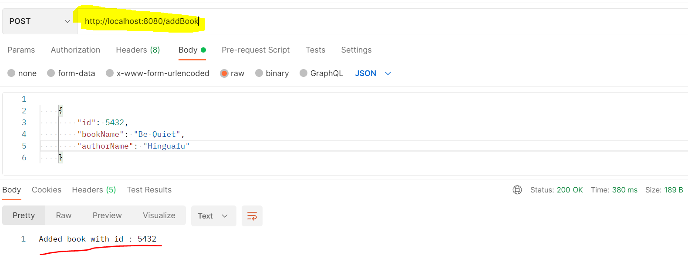

Let’s check in Mongo Database.

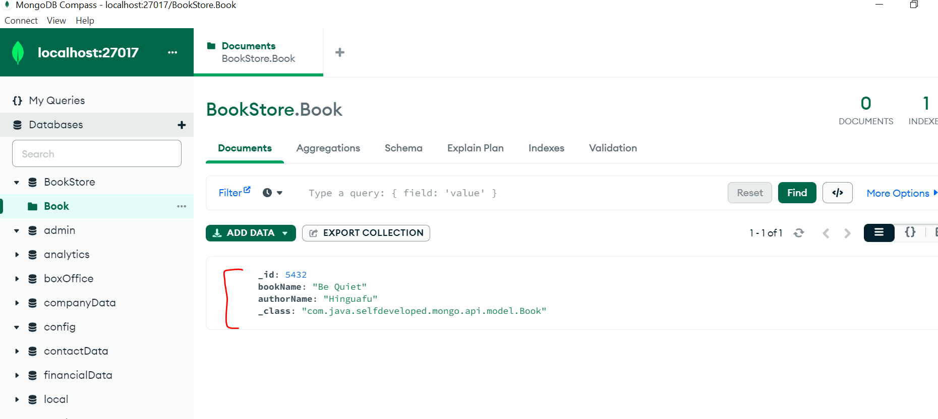

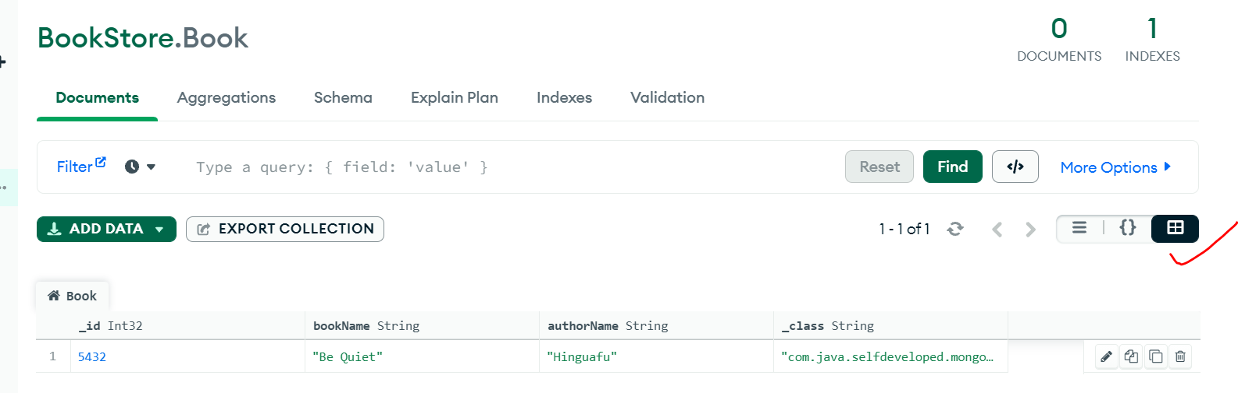

We can see in a different format as well like list, json and table.

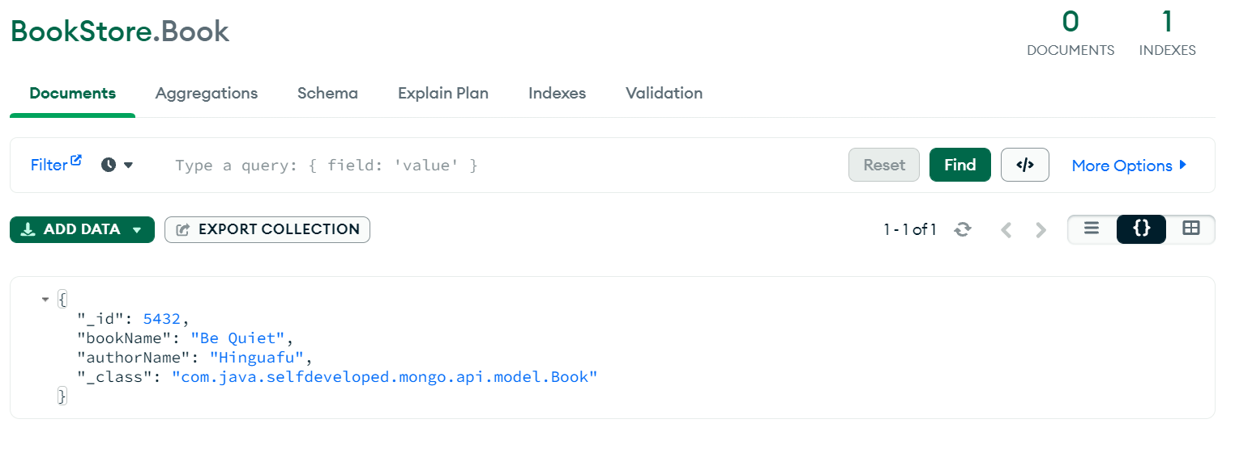

Let’s add another book also.

<http://localhost:8080/findAllBooks>

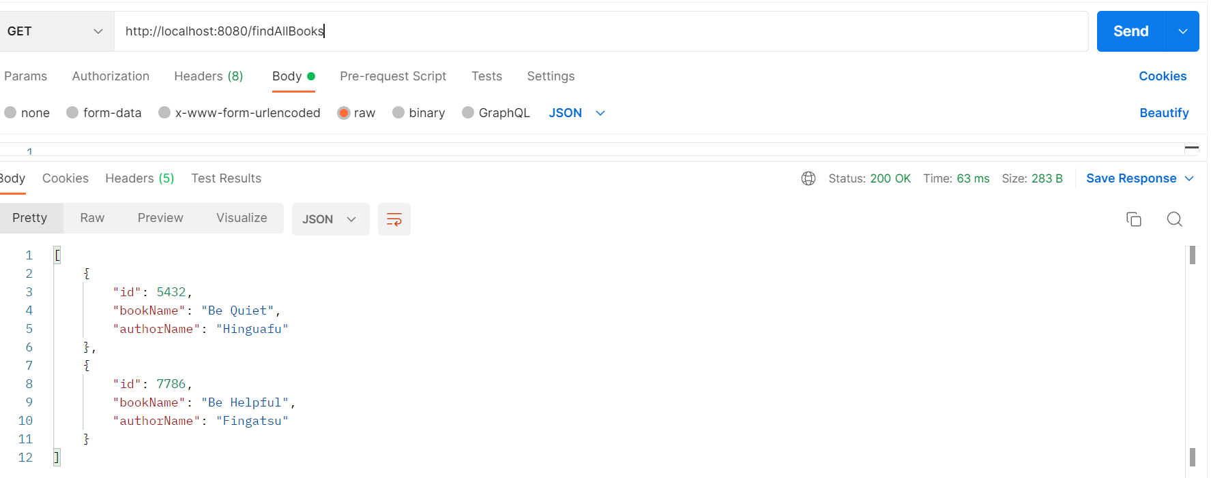

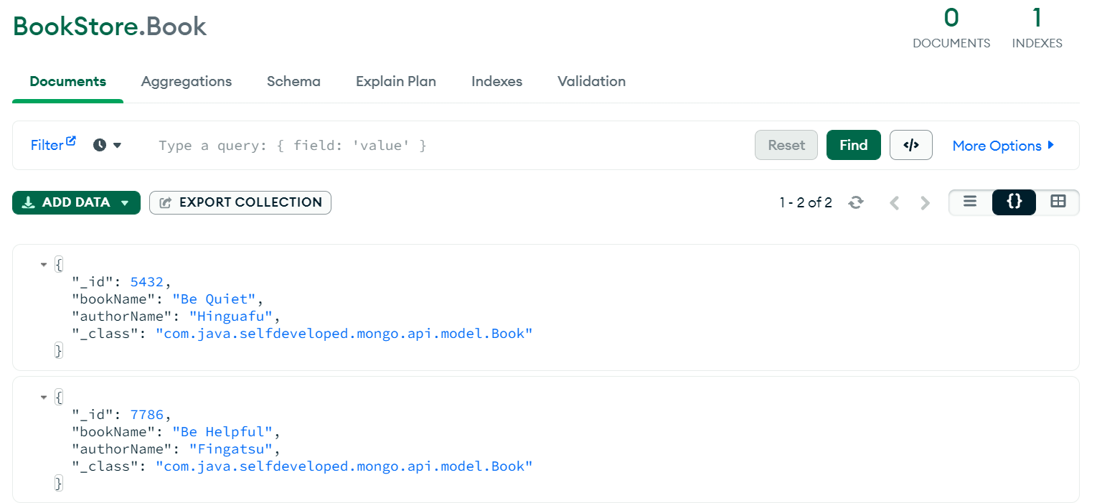

---------------------------------------------------------------------------------------------------------------------------------------

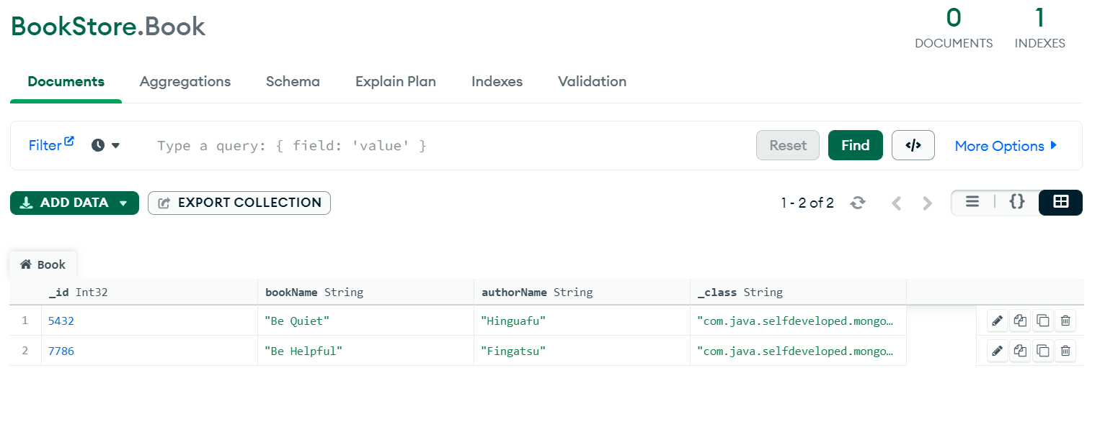

<http://localhost:8080/findAllBooks/5432>

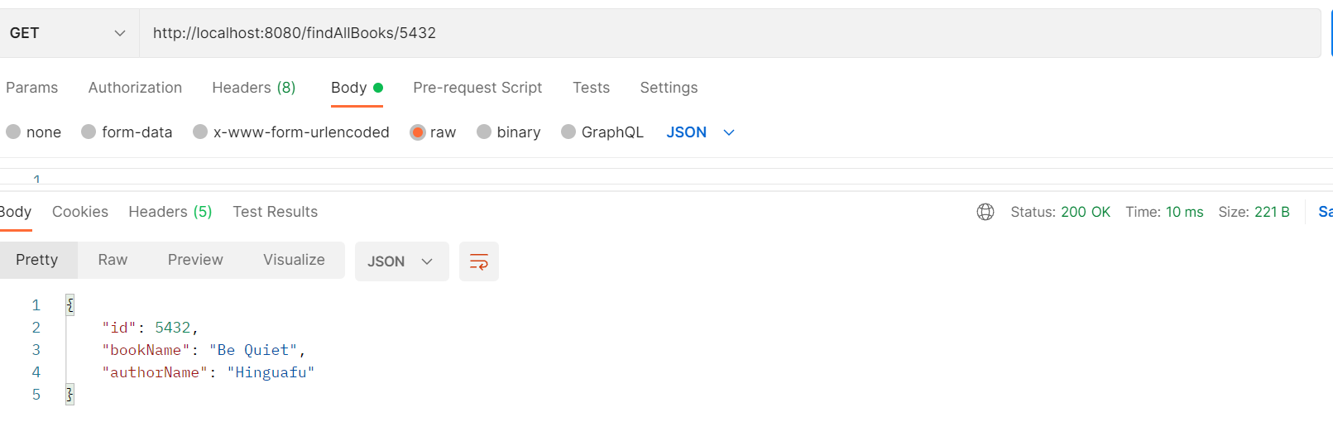

Let’s delete 5432 id record from DB

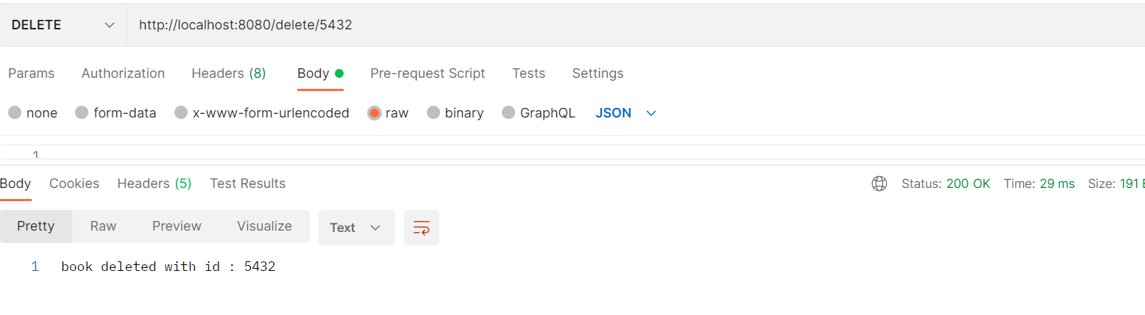

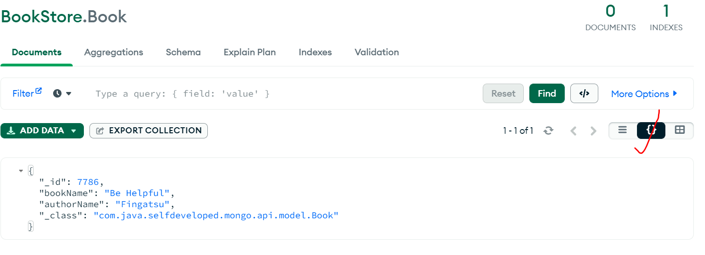

**Steps How we can do the setup for the MongoDB server.**

**First Download & Install MongoDB Community Servers**

<https://www.mongodb.com/home>

Go To Products -> Community Servers -> Download mongodb-windows-installer.( size : 482 MB)

<https://www.mongodb.com/try/download/community>

To Check-> windows start Menu -> Services -> Find MongoDB -> Right Click Start/Stop Server.

Alternatively open CMD -> Run AS Administrator -> net start/stop MongoDB

Now Our Server is Running…

In Order to use that Server, we need a **client,** orit’s called a **Shell** which allows us to send a **command** or **query** to the **server.**

For this you can open up the following path **C:\Program Files\MongoDB\Server\5.0\bin**

Now Run this **Mongo.exe** file.

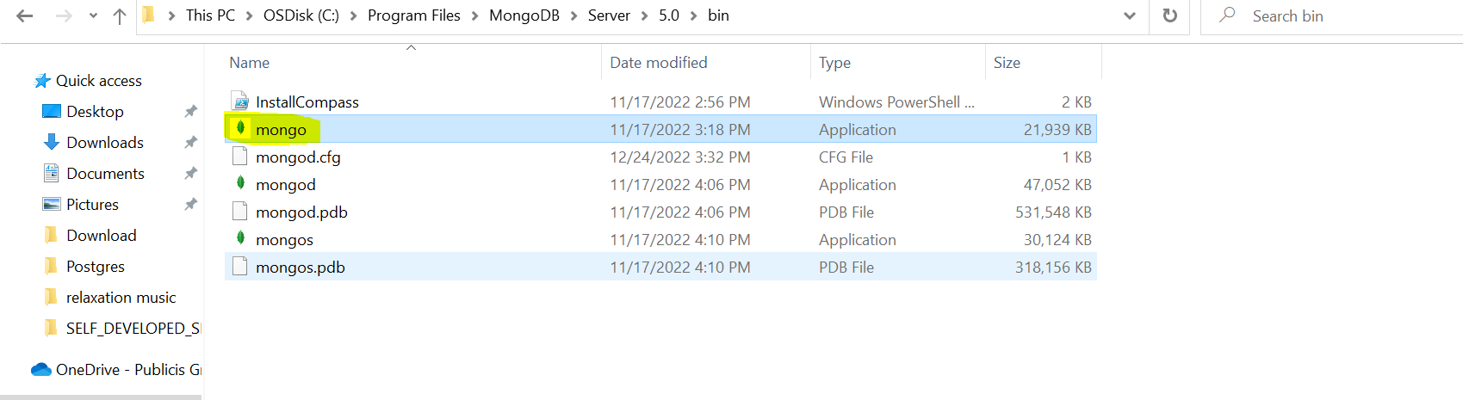

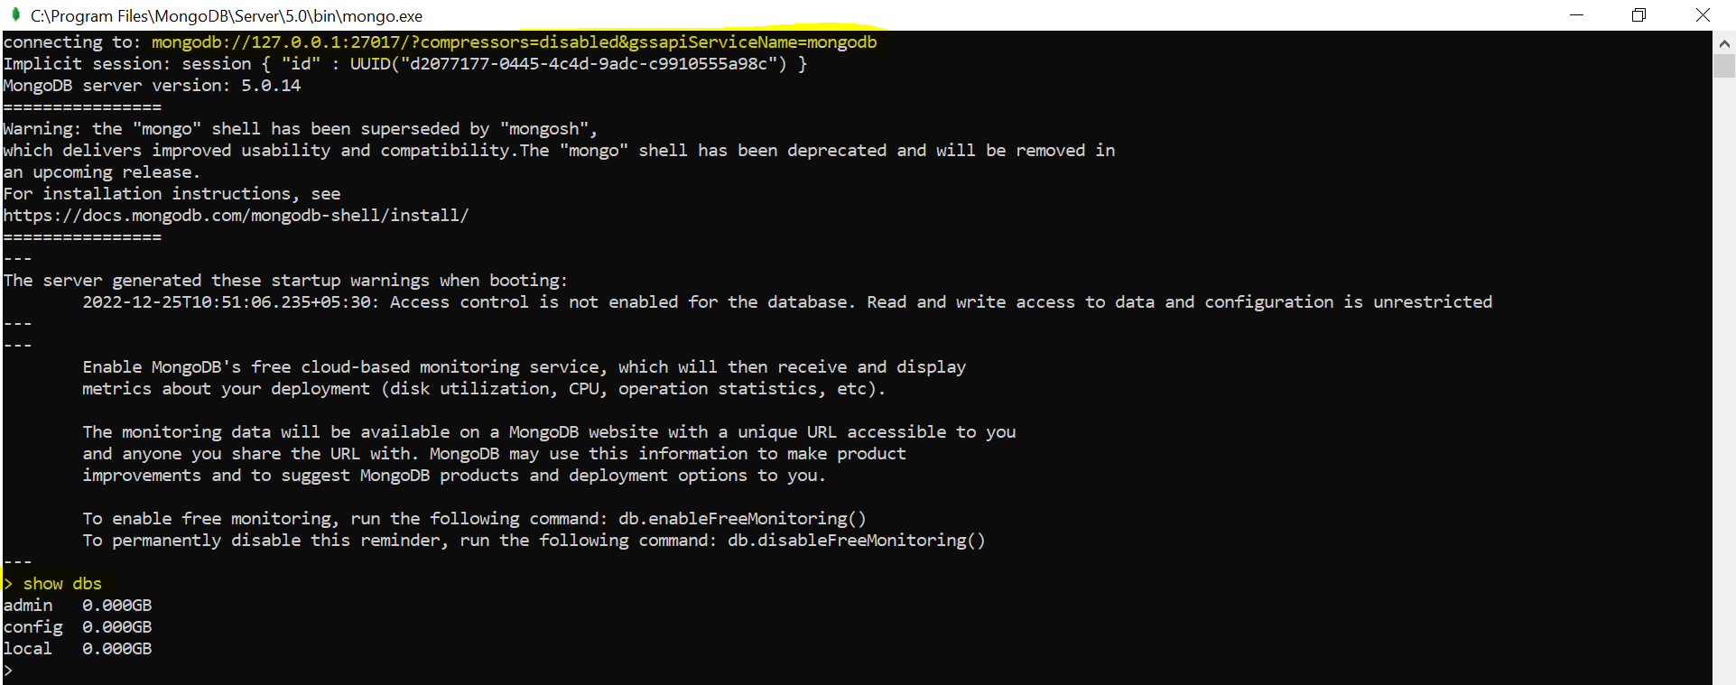

Now its connected to the MongoDB Server.

**Second Download & Install MongoDB Shell**

Now before going into deep dive or before writing queries to our mongodb database there is one additional tool we might need to install and that is **MongoDB Shell**.

Actually, we already did installed a **shell** together with the mongodb server in last discussion and we already did start the shell there. That was that thing that tool which we executed in the command line or by double clicking on it on windows to then connect to our running mongodb server. So, that tool we will use for inputting commands for sending commands to the server. but that shell might be the old shell but there is a newer shell available and you either already have that or you need to install it separately. If u already installed MongoDB shell named “**mongosh**” you already have the new shell but we don’t have in our bin folder.



Now to get that newer shell you can search for **MongoDB Shell**.

Download link-> <https://www.mongodb.com/try/download/shell>

On Windows-> start menu -> mongosh -> execute this command tool

First need to start your mongodb server then this shell will connect to your running server.

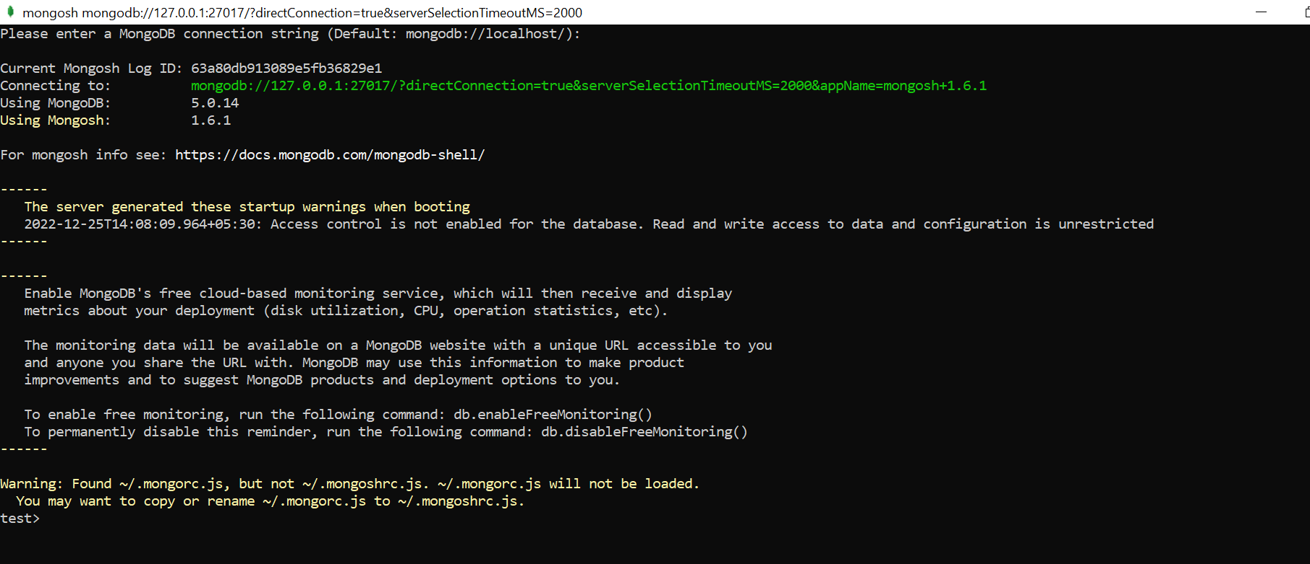

It will open mongosh shell cmd tool we just need to do enter.

We can now use this shell to interact with the database.

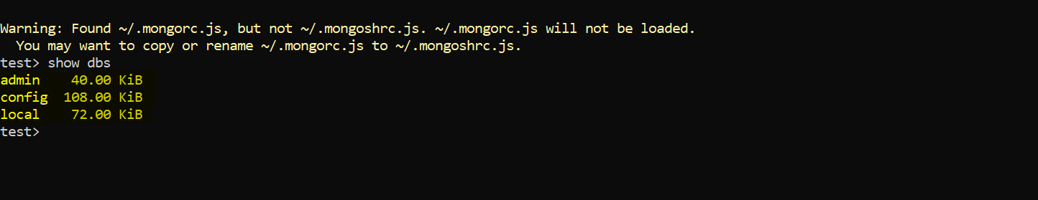

**>> Show dbs**